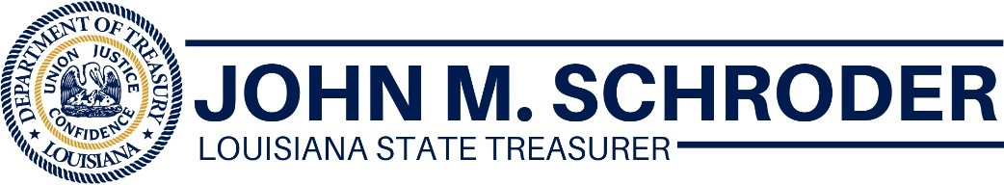
FOR IMMEDIATE RELEASE
July 10, 2020
Main Street Recovery Program Website Is Now Live
BATON ROUGE, LA – State Treasurer John M. Schroder today encouraged Louisiana business owners to visit the Main Street Recovery Program’s new website, www.louisianamainstreet.com, to find out if they’re eligible for up to $15,000 in grant money. The application process will begin July 28.
“In just a few weeks, businesses can start applying for money to help cover COVID 19-related expenses. We expect this money to go fast so you need to be ready to apply,” said Treasurer Schroder. “The new website contains key information and answers commonly asked questions. You can take a simple quiz to find out if your business is eligible. This is a great resource.”
Act 311 set aside $275 million for the Main Street Recovery Program. For the first 21 days, grants will be given to businesses who didn’t receive federal assistance or insurance payments. Within 60 days, the program plans to award $40 million to businesses owned by veterans, minorities and women.
Information that can be found on the website includes:
- What documents will be needed to apply
- An eligibility quiz
- Key program dates
- How to receive email updates

###

